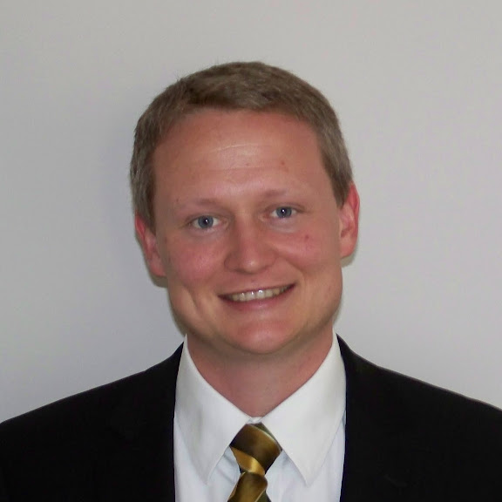
MATTHEW G. CHECKETTS, DO
Checketts Medical Consulting PLLC
A diplomate of the American Board of Internal Medicine – Participating in MOC

Mesa, Arizona | 480-269-4735 | Matthewchecketts@live.com

PROFESSIONAL SUMMARY
Board-certified internist with 7 years of post-residency practice spanning adult primary care, rural critical-access outpatient medicine, quality oversight, and hospice leadership.

LICENSURE & CERTIFICATION
• Diplomate, American Board of Internal Medicine — Board Certified, 2018-present • Arizona Medical License # 007545 (active & unrestricted)

EDUCATION & TRAINING
Internal Medicine Residency
2015 – 2018 Florida Atlantic University Charles E. Schmidt College of Medicine — Boca Raton, FL

Doctor of Osteopathic Medicine
2011 – 2015 A.T. Still University – School of Osteopathic Medicine in Arizona — Mesa, AZ

Bachelor of Science, Biology (Chemistry minor)
2006 – 2009 Brigham Young University–Idaho — Rexburg, ID

CLINICAL & LEADERSHIP EXPERIENCE
SABBATICAL – Mesa, AZ
12/2024 - Present

OAK STREET HEALTH — Mesa, AZ
01/2024 – 11/2024 Attending Physician, Senior-Focused Primary Care
• Managed complex chronic disease in panel of >400 Medicare patients (HCC-driven).
• Performed weekly multidisciplinary case reviews; mentored nurse practitioners.
• Documented to CMS standards.

GREATER REGIONAL MEDICAL CENTER — Creston, IA
06/2019 – 12/2023 Internal Medicine Physician, Critical-Access Hospital & Rural Clinic
• Outpatient adult medicine
• Medical Director, Diabetes Education & Nutrition
• Medical Director, Quality Management Committee – participated in interdisciplinary meetings with hospital leaders and executives to review quality efforts and measures

HOSPICE AT HOME OF ARIZONA — Mesa, AZ
2018 – 2019 Associate Medical Director
• Provided palliative care for hospice patients; chaired interdisciplinary team meetings when assigned by the medical director.

THE OFFICE OF JERRY E. OWENSBY MD — Mesa, AZ
2018 – 2019 Staff Internist
• Ambulatory management of chronic disease and acute presentations in high-volume suburban practice.

EARLY CLINICAL & TEACHING EXPERIENCES —
2011
• Peer-Assisted Learning Tutor & Group Session Facilitator, A.T. Still University

ACADEMIC & TEACHING ACTIVITIES
• Panelist, AAMC Southern Group on Education Affairs Conference (2018) — Integrating Behavioral Health & IM Training
• Team-Based Learning Session Leader, FAU IM Residency Academic Half-Day (2017)

PUBLICATIONS & PRESENTATIONS
1. Sehgal M, Hidlebaugh E, Checketts MG, et al. "Geriatrics Screening and Assessment." Primary Care: Clinics in Office Practice. (2019);46(1):85-96.
2. Co-author: “Alternative Medicine–Induced Hemolytic Anemia: A Case Report.” Palm Beach County Medical Symposium (2016).
3. Co-author: “HIV Awareness and Testing in South Carolina Lowcountry.” AOA Research Poster (2013).

HONORS & AWARDS
• "Compassionate Resident" – peer-voted, FAU Internal Medicine Residency (2016)
• Outstanding Medical Student Award – BJHCHS / ATSU (2015)

Updated 6/2025

