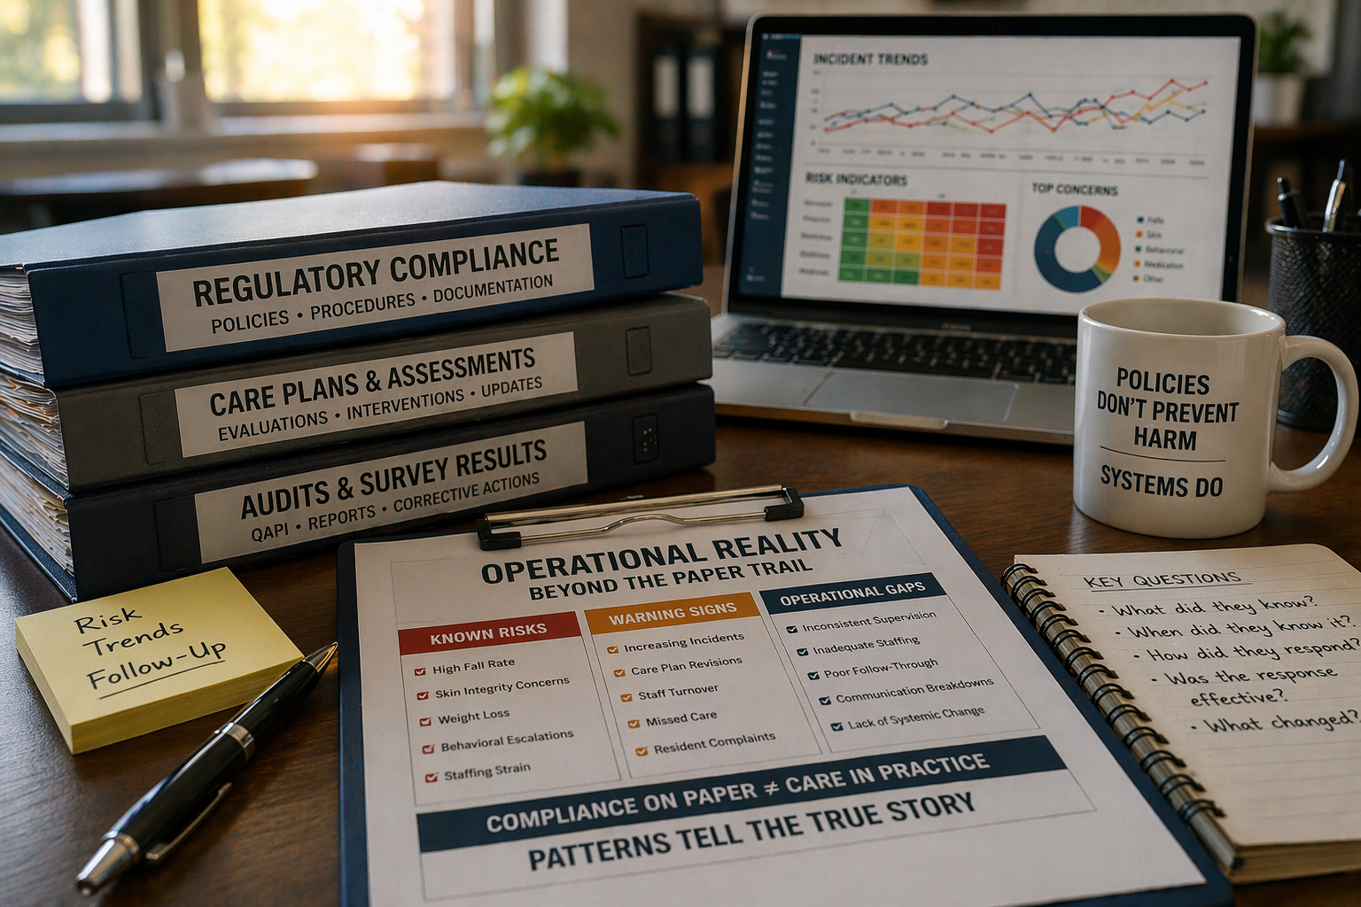

Regulatory Compliance vs. Operational Reality: Where Nursing Homes Actually Lose Cases
In nursing home litigation, “compliance” is often treated as the finish line. Facilities point to policies, completed forms, care plans, and survey outcomes as proof that they met their obligations. Defense teams frequently lean on the same materials to argue that the facility acted reasonably. Yet in practice, the compliance narrative often fails — not because documentation is missing, but because it does not reflect how the building actually functioned.
This is the central disconnect in long-term care cases: regulatory compliance is not the same thing as operational control.
Facilities do not lose cases simply because a policy was imperfect or a form was incomplete. They lose cases because the evidence shows that risk was foreseeable and persistent, and that the organization did not effectively manage it despite knowing it existed.

Compliance Proves Paper. Litigation Tests Systems.
Regulatory compliance asks whether a requirement was addressed:
- Is there a policy?
- Is there documentation?
- Were assessments completed?
- Did the facility “check the box”?
Litigation asks something else entirely:
- Was the risk foreseeable?
- Did the facility recognize escalation?
- Did the system adapt?
- Was harm preventable with reasonable operational control?
Facilities often assume that the first set of answers resolves the second. It does not.
A facility can be “compliant” in the survey sense and still be operationally unsafe in a way that creates civil exposure. Conversely, a facility can have imperfections in paperwork but still demonstrate reasonable operational control.
This distinction explains why compliance-based defenses frequently unravel once the focus shifts from what existed on paper to how care was actually delivered.

Why Compliance Arguments Fail in Practice
In litigation, compliance-based defenses often fail not because they are incorrect, but because they answer the wrong question.

Demonstrating that policies existed or assessments were completed does not address whether the facility exercised reasonable control over known risks.

As a result, compliance arguments frequently weaken once opposing counsel reframes the issue from “what was documented” to “what was done.”

Policies Written for Survey, Not for Practice
Policies are frequently drafted to satisfy regulatory requirements rather than to guide real-time decision-making in a complex clinical environment. As a result, they often read well but function poorly.
Common features of survey-safe, operationally weak policies include:
- Broad statements of intent without measurable standards
- Generic escalation language (“monitor,” “as indicated,” “notify MD”)
- Interventions that assume staffing capacity that does not exist
- No triggers that force interdisciplinary escalation
- No accountability mechanism when interventions fail
In litigation, a policy that exists but is not operationalized can be worse than no policy at all. It establishes an expectation and invites a simple question:
If this is your policy, why didn’t your facility do it?

How Staffing Arguments Are Tested
Staffing defenses are often framed in terms of numbers — minimums met, schedules filled, no regulatory citations.

In litigation, those arguments are tested differently:

• Were staff assignments aligned with resident acuity?
• Did staffing change as risk increased?
• Were high-risk residents clustered without adjustment?

When staffing remains static in the face of known escalation, compliance with minimums becomes less relevant than the facility’s failure to adapt.

Staffing: Where Reasonable Care Becomes a Math Problem
Staffing is where compliance narratives most often collapse.
Facilities may meet minimum staffing requirements, remain within budget, and produce complete schedules — yet still operate in a way that is predictably unsafe given resident acuity.
The operational question is not whether staff were present, but whether staffing was capable of executing the care plans the facility itself created.
Relevant considerations include:
- Assignment stability and experience mix
- Concentration of high-risk residents
- Coverage during predictable high-risk periods
- Use of agency or unfamiliar staff
- Supervisory presence when risk is known

Anonymized Example: Staffing That Met Minimums but Missed Reality
In one case, a facility demonstrated full compliance with staffing minimums. Payroll records were complete, and schedules reflected no regulatory shortfall.
What the record also showed was a progressive increase in acuity on a specific unit, including multiple residents requiring two-person assists, behavioral supervision, and frequent redirection. Staffing assignments remained unchanged despite these developments.
From an operational standpoint, the issue was not staff presence, but staff capacity. Compliance with minimums did not address whether the facility exercised reasonable control over known risk.

Care Plans That Document Failure Without Correction
Care plans often become compliance artifacts rather than operational tools. Updates occur, but outcomes do not change.
A common litigation pattern:
- An event occurs (fall, wound, behavioral incident).
- The care plan is updated to restate existing interventions.
- The same event recurs.
- Documentation reflects “continue” language.
- No meaningful operational change follows.
This is not merely imperfect care planning. It is evidence of a system that records failure without correcting it.

Anonymized Example: Recurrent Falls Without Change
In a recurrent-falls case, the resident’s care plan was revised multiple times over several months. Each revision referenced the same interventions: reminders, supervision as needed, call light access.
The falls continued.
What changed was not the intervention, but the frequency of documentation. There was no evidence of enhanced supervision, assignment modification, or escalation beyond routine care planning. The care plans demonstrated recognition of failure without operational response.

QAPI: The Compliance Feature Most Likely to Become an Exhibit
QAPI was designed as a quality improvement engine. In litigation, it often functions as a record of institutional knowledge.
QAPI becomes damaging when it reflects:
- Identification of recurring problems without resolution
- Repetition of the same action items
- Reliance on education rather than system redesign
- Absence of measurable corrective timelines
- Framing systemic failures as individual staff issues

Anonymized Example: Awareness Without Authority
In one matter, QAPI minutes repeatedly identified falls and staffing strain over multiple quarters. Action items were noted, but operational conditions remained unchanged. When incidents continued, the QAPI record was not viewed as diligence — it was viewed as proof that leadership knew the risks and failed to act.

Training and Competency: Attendance Is Not Performance
Facilities often rely on in-service logs to demonstrate competence. The operational question is whether training translated into changed practice.
Training evidence weakens when:
- Competency is not validated
- Performance is not audited afterward
- Repeat failures are treated as individual error rather than system failure

Anonymized Example: Training Without Change
A facility produced extensive training records related to fall prevention and transfer safety. Attendance was documented. Topics were listed.
Incident reports, however, continued to describe the same failures. There was no evidence of post-training competency validation or targeted supervision. Training documentation demonstrated repetition, not prevention.

The Minimum Standard Trap
Regulatory minimums establish a baseline — not a litigation ceiling.
Most cases do not turn on whether a minimum was technically met. They turn on whether the facility:
- Recognized escalation
- Individualized response
- Adjusted operations
- Prevented predictable recurrence
Compliance with minimum standards does not resolve those questions.

How Experts Interpret the Same Evidence Differently
Compliance review asks:
- Is the documentation present?
Expert operational review asks:
- Does the record show adaptation?
Assessments, care plans, training logs, QAPI minutes, and policies often demonstrate awareness. Whether they demonstrate control depends on what followed.
This distinction explains why cases that appear defensible on paper often weaken under expert analysis.

Where Nursing Homes Actually Lose Cases
Facilities most often lose cases where three conditions converge:
- Known risk
The record shows awareness of escalating or persistent danger.
- Static operations
Staffing, supervision, and interventions remain unchanged.
- Predictable recurrence
The harm is the next event in a documented pattern.
At that point, compliance arguments do not rebut foreseeability. They confirm it.

What This Means for Defense and Plaintiff Strategy
For defense counsel, compliance documentation must be reframed to demonstrate operational control, not just regulatory adherence.

For plaintiff counsel, the focus is often the opposite: using the facility’s own policies, QAPI records, and care plans to show that the organization knew what should have been done — and did not do it.

In either case, the outcome is driven less by the existence of compliance and more by the gap between policy and practice.

Closing Perspective: Compliance Explains What Existed. Operations Explain What Happened.
Regulatory compliance demonstrates that a facility created paperwork associated with care. It does not, by itself, demonstrate that the facility exercised reasonable operational control.
Courts evaluate decisions, not binders.
The central litigation question is not whether the facility knew what it was supposed to do, but whether it responded appropriately once it knew existing systems were failing.
When the record reflects awareness without action, documentation becomes evidence — not protection.
Facilities rarely lose cases because policies were missing. They lose cases because their systems tolerated known risk.
In that sense, documentation does not determine liability.
It reveals it.

Steven Smyth, LNHA, CNHA, HSE, CIFHA, BCPA, CMDCP
Nursing Home Administrator | Expert Witness in Long-Term & Post-Acute Care
Steven Smyth Expert Consulting, LLC
https://www.stevensmythexpertconsulting.com

