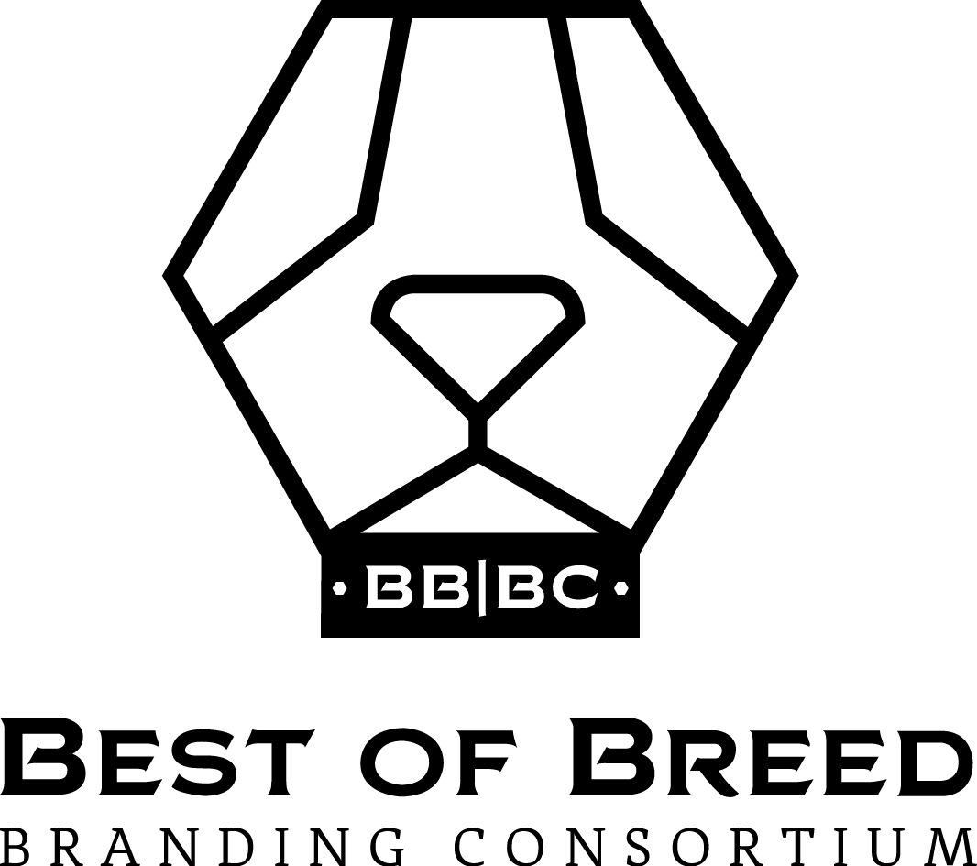

Three Critical Steps to Creating and Protecting Your Trademark

Rob Wallace
Expert Witness, Trademarks, Trade Dress, Copyright Infringement

Trademarks are everywhere. They’re embodied in logos and symbols (Nike’s Swoosh), color schemes (John Deere’s green and yellow), numbers (501 jeans), slogans (“Eat Fresh”), and even shapes (Method’s product packaging). They’re memorable. They distinguish products and services of one provider from those of another, ensuring that customers do not confuse their source. In fact, avoiding consumer confusion is trademark law’s primary goal.

Branding is the synthesis of product communication delivered at every consumer touch point. It's the product’s story and how that story is communicated in every consumer interaction.

The concepts of trademarks and branding are intertwined, often indistinguishable from one another. A brand may be a trademark, and a trademark may be a brand. But in many ways, these two concepts are at odds with one another, and understanding how and why they differ is critical.

Jonathan Gelchinsky, a lawyer who heads the trademark practice at Pierce Atwood LLP in Portland, Maine and Boston, Massachusetts, and Rob Wallace, Managing Partner of brand consulting firm Best of Breed Branding in New York, discuss and shed some light on the inherent tensions between trademark law and branding best practice, and provide insights on how to balance these tensions in order to develop and maintain a successful brand identity.

1. Be distinctive, not descriptive

The ever-increasing hyper-proliferation of new brands in virtually every category makes finding a proprietary brand name increasingly harder. Branding best practices recommend that your brand name intuitively describe your brand’s benefits. On the other hand, trademark law provides little or no protection to marks that are merely descriptive of a quality, feature, purpose, or other aspect of their product or service.

Gelchinsky explains that “there is a spectrum of distinctiveness in trademark law, and the more distinctive a mark is, the more protection it will garner under the law to keep other similar marks at bay. The strongest marks are fanciful or made-up words, such as EXXON and KODAK. They communicate nothing about the product at the outset because they have no defined meaning and have generally not been used before. Next are marks that are arbitrary for the goods or services. These are existing words used in an arbitrary way, such as APPLE for computers and electronics and CAMEL for cigarettes. They too communicate no information at the outset of their use about the goods. With these two categories of marks, consumers have to be educated and learn to make the association between the marks and the products and services they represent, and this is what makes them strong trademarks. Next down the chain are terms that are suggestive of some feature or characteristic of the goods and services. These are terms that convey some information about the goods and services, but not in an immediate way. They require the consumer to stop and think about the mark in order to make the mental connection between the mark and the goods. Classic examples of such marks are WINDEX, COPPERTONE, WITE-OUT and BAND-AID.”

“This leads us to the category of descriptive marks,” Gelchinsky continues. “These are terms that immediately convey some information about the goods they represent, such as the purpose, use, or other characteristics of the product. Trademark law does not initially protect marks that fall into this category, with the idea that the mark is not capable of distinguishing the goods when it merely provides information about those goods. Such marks are capable of legal protection only after they have been used for a sufficient amount of time and have achieved ‘secondary meaning’ as a trademark – an often difficult standard to meet.”

Wallace acknowledges the legal downsides to adopting descriptive marks to identify a brand, but adds that “creating awareness and recognition of a new, non-intuitive brand name requires significant time and money. Take, for example, the fanciful trademark STARBUCKS. That brand is now over 40 years old, and it took more than two decades to turn that name into the household word that it has become.”

Rob continues, “Descriptive brand names like SPORTS ILLUSTRATED and CHAR-BROIL more quickly communicate their brand story, but are a lot harder to protect.” Jon adds, “These descriptive marks were not legally protectable on day one, and had to build up secondary meaning before they were protected by law.”

2. Don't let your brand name become a noun or a verb

A related point of tension between trademark law and branding best practices is the desire of a marketer “to actually build the brand name into the consumer vernacular and make it ubiquitous,” says Wallace. This is something that happens over time, well after a brand is adopted and used. “Make the brand name stand for the service it provides, such as ‘I’ll Google that’ or ‘please FedEx that to me,’ and it enters the public’s consciousness in a way that results in more sales and consumer attention.”

Jon cautions, however, that “trademark law strongly disfavors using a mark as a noun or a verb. Doing so can result in what’s called ‘genericizing’ a trademark, that is, the mark becomes the generic term for the product or service and, at that moment, it completely loses all of its trademark significance and can never receive protection under trademark law. KLEENEX and XEROX are examples of marks that have come close to losing their status as trademarks. One does not ‘Xerox’ a document, but can photocopy a document using a Xerox copier. Kleenex is a brand of facial tissue, not a synonym for one. People may not realize this, but words like aspirin, escalator, and cellophane were at one time protectable trademarks. But through misuse by the brand owners and the public, these terms became generic words to mean the very class of products they represent. They are no longer trademarks, meaning that they’re now free for anyone to use.”

3. Evoke your brand message without expressly stating it

There is a convergence of the dueling concepts that Jon and Rob discuss above, where a brand communicates some information about the product or service it represents, but does so in a way that requires thought process by the consumer to understand the message that is evoked by the mark. These are marks in the “suggestive” category mentioned above, which, from a legal standpoint are deemed to be distinctive at the very outset and do not require extensive use before becoming protectable.

Wallace further explains that these are “brands that are distinctive enough to differentiate, but still evoke some notion of the underlying product or service to the consumer. Take, for example, the marks FACEBOOK, AIRBNB, COPPERTONE, and OPEN TABLE. If a consumer breaks each one down into its component parts or roots, they can start to connect the dots to learn something about what the mark represents. Yet, the message isn’t so obvious that the marks fall victim to the descriptiveness problem that Jon talks about.

Another important benefit of suggestive marks, according to Wallace, is that “they reflect a level of creativity on the part of the brand owner, which then may signal to consumers that the products or services sold under the brand will be smart and fun. NETFLIX, GROUPON, and KRISPY KREME are good examples. It’s generally a win-win approach, provided that the brand can catch on in the right way.”

Jon concludes that “striking the right balance, communicating enough information to consumers without communicating too much too quickly, is one of the keys to ensuring its success as both a brand and a trademark.

In future articles in this series, Jon and Rob will explore ways to create and evolve brand identities without resulting in a loss of legal protection, and other ways in which trademark law intersects with the branding industry.

Rob and Jon welcome questions, feedback, and insights. Jon can be reached at jgelchinsky@pierceatwood.com. Rob can be reached at rob@bestofbreedbranding.com.

