CDR-4828
A Tale of Two (or more!) Methods: A Case Study Comparing Loss of Productivity Analyses
John A. Armstrong PSP; Matthew Marzilli PSP

Abstract
The quantification of lost productivity is one of the most contentious and challenging aspects of construction claims. While numerous methodologies exist, a lack of comprehensive, real-world data often forces experts to rely on methods that may not be the best fit for the circumstances, leading to disputes over their applicability and reliability. What if a project existed with records so meticulous that multiple industry-standard quantification methods could be applied and their outcomes directly compared?

This paper presents a unique case study of a large-scale construction project that maintained exemplary project records, providing a rare opportunity for a side-by-side "apples-to-apples" comparison of several widely accepted loss of productivity quantification methodologies. By applying techniques such as the Measured Mile, industry-specific studies, and other common approaches to the same robust dataset, this analysis moves beyond theoretical debates.

The study reveals interesting and sometimes surprising divergences in the results, providing critical insights into the inherent biases and sensitivities of each method. The findings will equip practitioners with a deeper understanding of how the choice of methodology can significantly influence the outcome of a claim. More importantly, this paper offers pragmatic, data-driven advice on selecting the most appropriate and defensible methodology for a given set of facts, ultimately empowering stakeholders to navigate complex productivity claims with greater confidence and clarity.

Contents
Abstract 1
Introduction 3
Compounding Effects of Impact Events 3
Major Critical Path Delays 3
Resulting Loss of Productivity 4
Exemplary Project Records 5
Inefficiency Methodologies Exercised 5
Measured Mile 5
Measured Mile Methodology Description 5
Appropriate Use of Measured Mile Methodology 6
Measured Mile Methodology Results 6
MCAA Model 7
MCAA Model Methodology Description 7
Appropriate Use of MCAA Model Methodology 8
MCAA Model Methodology Results 9
Total Cost 9
Total Cost Methodology Description 9
Appropriate Use of Total Cost Methodology 10
Total Cost Methodology Results 10
Ibbs Productivity Formula 11
Ibbs Productivity Formula Methodology Description 11
Appropriate Use of Ibbs Curve Methodology 13
Ibbs Curve Methodology Results 13
Summary, Quantification, and Comparison of Results 13
Conclusion 14
References 14

Introduction
Quantifying lost productivity is one of the most challenging aspects of construction claims. Unlike other objective analyses like forensic schedule analyses to critical paths, loss of productivity analysis can be more subjective and introduce greater uncertainty when quantifying damages.

The choice of methodology can notably influence the outcome of a claim, as different methodologies can calculate substantially different results. In addition, the availability of specific project data sets and the quality of those data sets can dictate what methodologies are applicable and the results that those methodologies calculate.

The “Use of Mechanical Contractors Association of America Method in Loss of Productivity Claims” Editorial defines productivity in relation to as construction as follows:

“Productivity is a measurement of work efficiency. It is usually defined as work output divided by work input”

CDR-4828 examines the compounding effects of impact events, the associated loss of productivity, and the application of several industry-accepted loss-of-productivity methodologies used to quantify the damages to a wastewater construction project (“Project”). CDR-4828 applies four (4) separate industry-accepted analyses: the Measure Mile Method, Total Costs, the Mechanical Contractors Association of America (MCAA) Model, and the Ibbs Formula. Specifically, CDR-4828 compares the results of its Measured Mile Analysis, to each of the latter three methodologies referenced above.

First, CDR-4828 discusses the Project issues and their compounding effects on the Project. Next, the analysis will describe each loss-of-productivity methodology applied, its applicability and appropriate use, and, finally, the corresponding results when applied to the Project under analysis.

Compounding Effects of Impact Events

Major Critical Path Delays
The wastewater construction project analyzed in this study encountered numerous issues throughout its life. Although this study does not analyze critical path delays, numerous major delays contributed to the Project’s loss of productivity. Thus, merging these two issues into relation. The major critical path delay events of the Project can be summarized as follows:

- Issues associated with owner-furnished components:

  - Upon receipt of specific owner-furnished equipment (OFE), the contractor planned to rig and erect the components into place, utilize an efficient and planned “just-in-time” delivery and installation method. However, the size of the OFE and the location of lifting points of the components delivered to the site were not consistent with what was shown in the design documents. For example, the Contractor learned that the prefabricated pipe spools supplied by the owner were approximately 20% heavier than outlined in the bid documents, thus forcing the Contractor to have to completely redesign and restructure its rigging and lift plans. This ultimately resulted in double-handling materials, re-designing crane pads and crane pick plans, and additional installation time.

  - In addition to the above, the OFE equipment had additional fabrication issues that affected installation. For example, there were fabrication issues with fastening the equipment in place. This caused many pipe spools and prefabricated pipe racks to be out of tolerance after erection and required extensive unplanned field modifications to satisfy the Contract's technical requirements.

- Piping, Electrical, and Large Equipment Design Changes

  - The Owner issued numerous design changes to the piping, electrical, and large equipment. These issues were caused by three separate items: missing information on the Contract drawings, design changes to include work that was not completed by the owner’s vendors, and design changes to correct design errors.

- Outage Scheduling

  - The Contractor absorbed impacts from the Owner revising multiple planned plant outages. The Contractor’s prioritization of design submittals, procurement, and sequence of construction all were planned in correlation with the treatment plant outage schedule, and the revision of that schedule affected all three components.

- Design Issues that Affected the Ability to Utilize Prefabricated Infrastructure Components

  - The owner issued continuous design corrections to infrastructure items associated with steel columns that connected the main decking. These issues delayed construction and the ability to prefabricate much of the steel column infrastructure prior to construction and forced the Contractor to stick-build the columns.

Resulting Loss of Productivity
Due to numerous compounding critical path delays, the Contractor experienced a multitude of global and compounding effects that contributed to a loss of productivity. Those effects can be summarized as follows:

- Indirect Support was affected by the continuous delays, including but not limited to adhering to change management documents, revamping of schedules and plans, rebudgeting, re-planning resources, the revision of procurement efforts, and the overall fatigue (inefficiency) of management personnel due to increased workload.

- Direct Support was significantly impacted. Field crews were required to respond to constantly changing plans, perform out-of-sequence work, remobilize between the most heavily impacted work fronts, and work significant overtime to recover from resulting delays. These impacts disrupted the development of work “rhythms” and extended the learning curves for performing new tasks or working in new areas. Furthermore, extended overtime leads to fatigue and reduced productivity. Many of these impacts occurred simultaneously and impacted (directly and indirectly) the same construction operations. This is an additional layer of complexity, amplifying the effects of any particular issue.

- Trade and Crew Stacking is the result of multiple changes, delays, and disruptions. Trade and crew stacking result in unsustainable concurrency, over-density of work areas, safety hazards, increased management costs, difficulty in construction oversight of crews, and overall slowed production rates.

- Cumulative Changes is a widely recognized cause of inefficiency. This Project experienced 30%-40% of changes in relation to the baseline Contract value. Cumulative changes affect indirect support, crew redirection, work start-ups and stoppages, rework, and construction sequencing, and are detrimental to the Project’s overall workflow.

- Design Errors were a large contributor to the Project delays. Approximately 10% of the Project change value was a result of design errors.

- An increase in Night Shift Work was utilized to recover the schedule. However, this significantly slowed progress and caused inefficiencies. The Contractor had to retain more labor, more management, operate at suboptimal hours, all of which slowed the production of the average labor hour. The greater the labor required, the lower the quality of the labor pool, as the Contractor must reach deeper into the market.

Exemplary Project Records
The Contractor’s record-keeping was generally consistent and often exceeded the tracking practices expected for a project of this size and type.

The Contractor’s cost, craft-hour, and quantity tracking were detailed and utilized a cost coding hierarchy. Direct costs to perform select scopes of work (i.e., electrical, mechanical piping, structural steel erection) were further decomposed by installed material, material size, and location. Project-specific overhead and indirect expenses were segregated from direct costs. The Contractor also ensured that potential and executed change-order costs were not included in direct or indirect costs.

The Contractor tracked actual spent craft-hours each week, along with confirmed quantities completed during the week. The Project Owner conducted a weekly audit of completed quantities and reconciled them with the contractor at the end of the week within the design model.

Inefficiency Methodologies Exercised

Measured Mile

Measured Mile Methodology Description
The Measure Mile methodology for loss-of-productivity analysis is often regarded as the gold standard for inefficiency analyses. Gatherinsights.com has an article named “Construction Measured Mile Analysis Guide
“, which defines the Measured Mile Analysis as follows:

”A method of productivity analysis that compares a section of work completed under normal, unimpacted conditions (the "measured mile") with a section of work affected by delays, disruptions, or inefficiencies. This allows for an objective, data-driven comparison to quantify lost productivity without the usual opinion and assumptions.”

In other words, the Measured Mile methodology compares production from an unimpacted period of work for a certain scope of work and compares it to the production of an impacted period of work for the same scope of work and then quantifies the delta between the two. The difference in production between the two periods (impacted & impacted) equates to the loss of productivity.

Equating production is typically measuring the number of units earned per man-hour expended, or the man-hours expended to produce a certain unit of measure. For example, the number of man-hours required to place linear feet of pipe. However, when man-hours expended cannot easily be tied to the production rate of an installed unit, the analyst can perform a Measured Mile Analysis based on earned revenue. By removing fixed costs like General Conditions, an analyst can calculate the how many dollars are earned per man-hour spent.

There are several ways that inefficiency can be calculated in a Measured Mile Analysis between the Unimpacted and Impacted Periods. Table 1 below shows an example of the results of a unit based Measured Mile Analyses, which compares the man-hours required to place linear foot (LF) of 48” of pipe. This shows that the contractor spent .92 hours placing 1 LF of pipe in the Unimpacted Period and spent 1.84 hours placing 1 LF of pipe in the Impacted Period. Thus, there was .91 hours lost per LF of pipe placed in the Impacted Period, which equates to a 99% Inefficiency Rate. With 13,500 LF placed in the Impacted Period, the contractor lost 12,338.46 hours (.91 x 13,500 LF) in that period. With a Labor Rate of $85.20, and 12,338.46 hours lost, the cost of the loss of productivity equates to $1,051,236.92.

Table 1
Unit Based Measured Mile Example
Production Metrics
Row | Period of Work | LF Installed | Man-Hours Expended | HRs per LF
A | Unimpacted Period: Jan-23 thru Oct-23 | 22,100.00 | 20,400.00 | 0.92
B | Impacted Period: Oct-23 thru Jun-24 | 13,500.00 | 24,800.00 | 1.84
C | Inefficiency Variance (HRs) (B-A) |  |  | 0.91
D | Inefficiency Rate (%) (C/A) |  |  | 99%
Loss of Productivity Equation
Row | Metric |  |  | Hrs/Rate/Loss
E | Lost Hours (BxC) |  |  | 12,338.46
F | Labor Rate |  |  | $85.20
G | Measured Mile Loss of Productivity ($) (ExF) |  |  | $1,051,236.92

Appropriate Use of Measured Mile Methodology
The Measured Mile methodology is often regarded as the gold standard of inefficiency analyses because it is the most objective. With sufficient quality data, the analysis proves an unimpacted production rate for specific scope of work, or at least the project as a whole. When the analysist can delineate between an unimpacted period and an impacted period, the difference in production or efficiency can objectively be calculated.

While the most sought-after analysis, there are times when the Measured Mile is not the best fit for a project. For example, if the analyst cannot truly define an unimpacted period (or area), then the benchmark unimpacted period is clouded and not truly defined. In addition, if there are not accurate project records, then the input data is not as reliable. When quality input production data is available, an analysist my rely on a revenue based Measured Mile, which relies on modified payment applications. Payment applications provide a fallback benchmark of production rate in lieu of unit production rates.

Measured Mile Methodology Results
The table below presents the loss of productivity for the major impacted trades and the overall loss of productivity on the Project. As a whole, a 32% total loss of productivity was experienced based upon the Measured Mile methodology across all trades on the Project. The percentage represents the proportion of lost productivity hours and anticipated hours, if the scope had not been impacted. The contributions of each trade are weighted based on the quantity of hours expended in each trade, thus the 32% is not an equal average of the four trades.

Table 2
Methodology | Electrical | Large Equipment | Mechanical Piping | Structural Steel | All Scopes
Measured Mile Loss of Productivity | 33% | 54% | 37% | 28% | 32%

MCAA Model

MCAA Model Methodology Description
The Mechanical Contractors Association of America (MCAA) methodology is often utilized when an unimpacted period cannot be identified, thus impeding the ability to reasonably perform a Measured Mile Analysis. The MCAA methodology factors in sixteen (16) different Impact Factors that are listed below in Table 3.

Table 3
MCAA Impact Factors
1. Stacking of Trades | 9. Beneficial Occupancy
2. Morale and Attitude | 10. Joint Occupancy
3. Reassignment of Manpower | 11. Site Access
4. Crew Size Inefficiency | 12. Logistics
5. Concurrent Operations | 13. Fatigue
6. Dilution of Supervision | 14. Ripple Effect
7. Learning Curve | 15. Overtime
8. Errors and Omissions | 16. Season and Weather Change
The MCAA Method has a subjective component which requires the analyst to apply one of the following three designations for all applicable Impact Factors:
- Minor
- Average
- Severe

For the sixteen (16) impact factors listed in Table 3 above, there are standard “% of Loss per Factor” that are assigned based on the designation (minor, average, severe) chosen for each applicable Impact Factor. Those subject percentages are in Table 3 below.

Table 4
MCAA Impact Factors - Loss per Factor
Factor | Percent of Loss per Factor
Factor | Minor | Average | Severe
1. Stacking of Trades | 10% | 20% | 30%
2. Morale and Attitude | 5% | 15% | 30%
3. Reassignment of Manpower | 5% | 10% | 15%
4. Crew Size Inefficiency | 10% | 20% | 30%
5. Concurrent Operations | 5% | 15% | 25%
6. Dilution of Supervision | 10% | 15% | 25%
7. Learning Curve | 5% | 15% | 30%
8. Errors and Omissions | 1% | 3% | 6%
9. Beneficial Occupancy | 15% | 25% | 40%
10. Joint Occupancy | 5% | 12% | 20%
11. Site Access | 5% | 12% | 30%
12. Logistics | 10% | 25% | 50%
13. Fatigue | 8% | 10% | 12%
14. Ripple Effect | 10% | 15% | 20%
15. Overtime | 10% | 15% | 20%
16. Season and Weather Change | 10% | 20% | 30%

After designations have been made to each applicable MCAA factors, the factors must be applied for the loss of productivity equation. To correctly apply the factors, the percentages are applied to the expected/planned labor hours, and not the actual labor hours. Applying the percentages to the actual labor hours would overstate the loss of productivity.

Prior to applying the percentage of inefficiency to a task, all applicable factors are added together prior to applying them to the expected hours for a task. For example, if the MCAA methodology is applied to installing LF of pipe as reviewed in the above Measured Mile methodology example, a calculation would be as follows:

Table 5
MCAA Factors Applied
Factor | Designation | % Loss
Stacking Trades | Average | 20%
Learning Curve | Minor | 5%
Site Access | Severe | 30%
Total Percentage Inefficient |  | 55%
MCAA Calculation
Item | Metric
Expected Hours | 1200
Total Percentage Inefficient | 55%
Inefficient Hours lost | 660

Appropriate Use of MCAA Model Methodology
While not as objective and reliable as the Measured Mile, the MCAA Method provides a framework and process (structure) for quantifying loss of productivity. For example, each project is measured against the same set of 16 Impact Factors as detailed above. In addition, the MCAA is someone nimble in a sense as not all Impact Factors have to be utilized, and should not be, but the wide range of 16 different factors allows for a wide range of disruptions to be factored in as necessary.

Vulnerabilities of the MCAA Method are associated with the human element of the subjectivity of the applicable of the Impact Factors. In addition, each factor is applied at only one of the 3 discussed designations: minor, average, severe. Further, the analyst should have good reason to apply Average and Severe designations to specific Impact Factors, due to the high loss percentages associated with them. Finally, the analyst should also be cognizant of the risk of double-dipping on issues between overlaying the Impact Factors. The MCAA is not an exact calculation like the Measured Mile and relies on percentages that are developed from assumptions of historical industry data.

MCAA Model Methodology Results
Below in Table 6 shows productivity loss percentages on the Project based on the MCAA productivity factors. In addition, the table compares each trade’s loss of productivity percentage to the Measured Mile results. The number and severity are left to the practitioner; however, best practices recommend applying two to five of the factors to avoid “double-dipping.” The severity of each of the factors was determined by surveying project personnel with firsthand knowledge of the Project and compared against the Project’s contemporaneous records.

Table 6
Methodology | Electrical | Large Equipment | Mechanical Piping | Structural Steel | All Scopes
2 Largest Factors Applied | 45% | 45% | 45% | 40% | 35%
3 Largest Factors Applied | 60% | 60% | 60% | 55% | 50%
4 Largest Factors Applied | 75% | 75% | 75% | 70% | 65%
5 Largest Factors Applied | 90% | 90% | 90% | 82% | 80%
Measured Mile Loss of Productivity | 33% | 54% | 37% | 28% | 32%

In every instance, the MCAA factors resulted in a higher percentage loss of productivity than that calculated using the Measured Mile methodology.

Soley as a comparison exercise for this analysis, to target MCAA results that are similar to the Measured Mile results, the number and severity of the productivity factors were “backed-in”. However, it is not recommended to back-in analysis factors to target specific results. Below is a comparison of potential loss-of-productivity factors derived from the MCAA for the electrical scope.

Table 7
Methodology | Minor | Average | Severe
2 Largest Factors Applied | 20% | 45% | 80%
3 Largest Factors Applied | 25% | 60% | 110%
4 Largest Factors Applied | 30% | 75% | 135%
5 Largest Factors Applied | 40% | 90% | 160%
Measured Mile Loss of Productivity | 32%

Selecting four or less factors with a “minor” severity ranking resulted in a loss of productivity percentage similar to what was calculated by the Measured Mile methodology.

Total Cost

Total Cost Methodology Description
The Total Cost methodology for construction claims calculates damages to a contractor by taking their actual total cost to complete the project and then subtracting their bid price from that amount. This method is typically used if certain other data sets are not available, as it does not account for the contractor’s performance and assumes that there were no issues with their bid price.

Modified Total Cost methodology is a variation of the Total Cost methodology. Similar to Total Cost, this methodology also relies on the accuracy of the contractor’s bid. However, in contrast to Total Cost, the Modified Total Cost methodology calculates damages to a contractor by adjusting their total cost in some format and then subtracting their bid amount. This is utilized when specific costs are available to be isolated and deemed unfit for the damages analysis. For example, when contractor errors and/or performance issues can objectively be identified and segregated, then the contractor’s total cost can reasonably be modified.

Appropriate Use of Total Cost Methodology
The Total Cost methodology is often utilized for analyses when more certain data aspects of data sets are not available. One reliable aspect of a Total Cost Claim is that a contractor is compensated for their exact amount spent, making them fully whole for the damages absorbed.

There are uncertainties with the Total Cost methodology. For example, Total Cost relies on the contractor’s bid being fully reasonable and accurate. Further, this methodology does not factor in contractor performance issues. It assumes the contractor performed flawlessly.

The Modified Total Cost methodology has some certainties over Total Cost as the analyst has the ability to adjust for necessary issues like flaws in a contractor’s bid and/or portions of their performance.

While more customized than Total Cost, Modified Total Cost still has uncertainties. For example, not all bid and performance issues are able to be objectively segregated out. Further, not all issues are transparent and known, thus many remained masked in the overall cost of the Project.

Total Cost Methodology Results
Below is a table of the loss of productivity percentages based upon the Total Cost methodology (along with the comparison to the Measured Mile results). The percentages below are a ratio of lost hours compared against the expected hours. For example, the Total Cost methodology indicates that for every 100 craft hours earned on Structural Steel, the contractor incurred a loss of 41.

The Total Cost methodology takes into account the Contractor’s performance, including actual performance that exceeded the budget or estimate. It is plausible in this methodology for the contractor to offset losses in productivity caused by the owner with its own financial gains for scopes which its productivity was greater than what was budgeted. On the other hand, this methodology has the potential to conflate its own impacts and losses in productivity to those caused by the owner.

Table 8
Methodology | Electrical | Large Equipment | Mechanical Piping | Structural Steel | All Scopes
Total Cost Methodology | 0% | 135% | 55% | 41% | 51%
Measured Mile Loss of Productivity | 33% | 54% | 37% | 28% | 32%

In this case study, the contractor experienced a 33% loss of productivity in the execution of the electrical scope, as calculated using the Measured Mile methodology. The Total Cost methodology estimated a 0% loss in productivity. This is an example where the Contractor’s actual productivity during periods of little to no owner-caused impacts exceeded what the budget was based upon. Had the Contractor elected to use the Total Cost methodology, the contractor would essentially be “healing the wounds” caused by the Owner.

The other trades exhibit different trends. The Total Cost calculated losses in productivity for the other trades show a greater than those calculated by the Measured Mile methodology. Applying the Total Cost methodology would potentially lead to a false claim, a situation which the Contractor requests payment for damages it is not entitled to recover.

Ibbs Productivity Formula

Ibbs Productivity Formula Methodology Description
The Ibbs Productivity Formula methodology (“Ibbs methodology”) is a loss of productivity methodology developed by Dr. William Ibbs. The methodology develops an inefficiency percentage by first developing the Percent Change by dividing the change order hours by the total hours. The Percent Change is implemented in the following Ibbs Calculation to plot on the Y Axis: Y=2.4621D² - 2.169D + 1.0589. Table 4 and Figure 1 below show an example of the calculation in use.

Table 9
Ibbs Curve Calculation Example
Row | Item | Metric
A | Change Order Hours | 1,500
B | Base Hours | 10,000
C | Total Hours (A+B) | 11,500
D | % Change (B/A) | 15%
E | Ibbs Curve (Efficiency) (1-D) | 85%
F | Ibbs Curve (Inefficiency) (1-E) | 15%
G | Ibbs Calculation: Y=2.4621D² - 2.169D + 1.0589 (Efficiency) | 79%
H | Inefficiency (1-G) | 21%
I | Total Labor Hours Lost (BxH) | 2,110.53
J | Hourly Rate | $85.20
K | Total Labor Cost Lost (IxJ) | $179,816.94

Figure 1
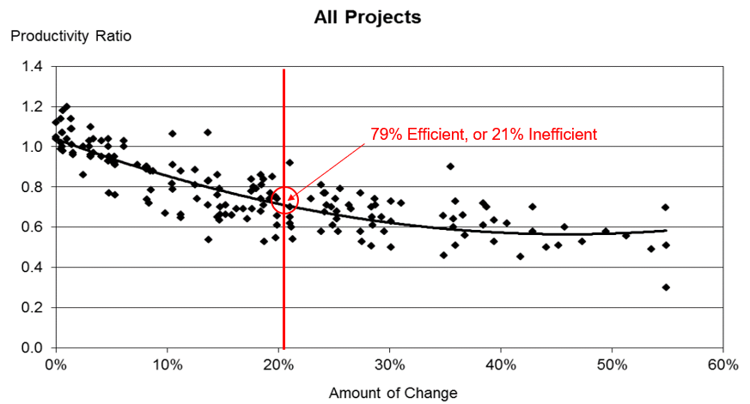

Ibbs also evaluated the effects of when changes occurred during a project’s duration. His later studies produced three separate equations to estimate the loss of productivity. Shown below is a graph taken from Ibbs’s 2008 article,
Evaluating the Cumulative Impact of Changes on Labor Productivity – an Evolving Discussion. Ibbs co-authored this article with Mr. Gerald McEniry and published in AACE’s Cost Engineering publication Volume 50, Number 12.

Figure 2
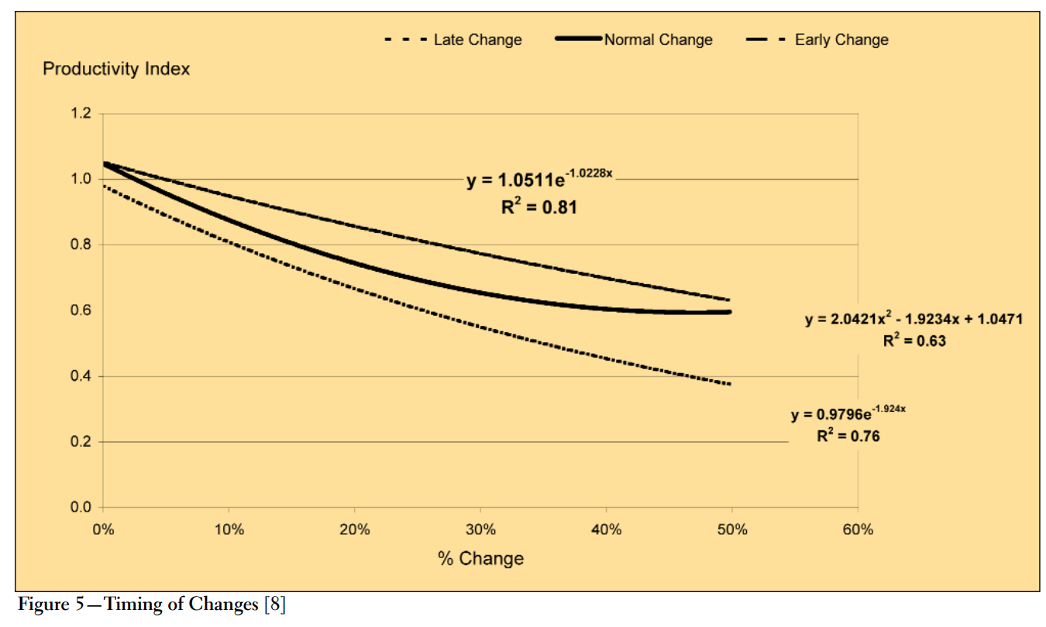

In this article, Ibbs demonstrates that the estimated loss of productivity value can change based on when the changes occur. For example, if a project has 30% change on a project, a project where changes occur late in the project can expect a loss of productivity of 45% whereas a project with early occurring changes can expect a loss of productivity of just 23%.

Appropriate Use of Ibbs Curve Methodology
The Ibbs methodology has an objective measurable aspect to it as the more changes (in cost value) a project experiences, the more inefficiency is calculated. The Ibbs methodology is often utilized as an accompanying loss of productivity calculation to help verify and add confidence to another applied methodology. For example, an analyst may utilize the Ibbs methodology after applying the Measured Mile or Modified Total Cost (or others) methodologies, to evaluate the comparison between the analyses. It is not uncommon to utilize more than one loss of productivity analyses, and the Ibbs methodology is often utilized in conjunction, due to the fact that it is simple to apply and calculate.

Ibbs Curve Methodology Results
Below is a table of the loss of productivity percentages based upon applying Ibb’s studies. The resultant loss of productivity when applying Ibb’s formulas spans values both greater and lower than what was calculated using the Measured Mile methodology.

Table 8
Methodology | Late | Normal | Early | Typical
Ibbs Formulas | 50.5% | 37.8% | 26.9% | 40.1%
Measured Mile Methodology | 32%

The Ibb’s formula for normal distribution of changes over the Project’s duration yielded a productivity loss of 37.8%, which is 5.8% higher than that calculated by the Measured Mile methodology. The criteria defined by Ibbs in his 2008 article regarding normal distribution of changes most closely model the conditions of this paper’s case study. The formula for Early distribution of changes, however, had a lower variance than the Measured Mile methodology. The variance between Ibbs’s formula for Early distribution and the Measured Mile methodology was only 5.1%.

A possible explanation for the higher productivity loss associated with the Ibbs methodology is that its formulas account for impacts on other trades and scopes. The Measure Mile methodology is typically applied to a singular trade and a discrete scope. The impacts on one trade can have a corresponding ripple effect on other scopes and activities. For example, reduced productivity in underground utility construction due to differing site conditions may delay the start of paving and shift it from a preferred to less preferred weather season. The impacts on the underground scope causes a compounding and ripple effect on paving and results in a loss of productivity to paving that otherwise had no direct relationship to the differing site conditions.

Summary, Quantification, and Comparison of Results
The table below summarizes the results of the four (4) loss of productivity methodologies applied in CD-4828 to the wastewater construction project studied.

Table 9
LOP Methodology | Loss of Productivity (%)
Measured Mile | 32%
MCAA Productivity Factor | 35% to 80%
Total Cost | 51%
Ibbs | 26.9% to 50.5%%

The Ibb's methodology produced loss of productivity factors similar to the Measure Mile methodology; however, detailed knowledge of Ibb’s studies is necessary in order to accurately and appropriately apply. The MCAA Productivity Factor methodology also produced some results that were aligned with the Measured Mile methodology, but, typically requires a conservative approach in identifying appropriate factors and accessing severity ratings. There is a real and material possibility that applying MCAA Productivity Factors can lead to an inaccurate quantification of loss of productivity damages.

Conclusion
The analysis of the Project presented in this paper highlights the significant variability inherent in quantifying loss of productivity within the construction industry. Through the rare opportunity provided by the Project’s exemplary records, we have demonstrated that even when using the same dataset, different industry-standard methodologies can yield vastly different results. As shown in the comparison of the Measured Mile, MCAA Factors, Total Cost, and Ibbs Formulas, the calculated inefficiency percentages ranged from as low as 26.9% to as high as 80% or more.

There is no single "de facto" best methodology for every construction dispute. While the Measured Mile remains the preferred "gold standard" due to its reliance on project-specific unimpacted data, its application is not always feasible or appropriate depending on the nature of the disruptions and the quality of the records. Ultimately, the "best" method is the one that is most appropriate and fitting for the specific facts of the case. For instance, while the Total Cost method might seem straightforward, this case study revealed how it can inadvertently "heal the wounds" of an owner-caused impact if the contractor’s baseline performance was exceptionally high, or conversely, conflate contractor-driven issues with owner-caused delays.

Applying these methodologies is not a simple clerical exercise; it requires deep understanding and experience. As demonstrated:
- MCAA Factors require a disciplined, conservative approach to avoid "double-dipping" and subjective overreach.
- Ibbs Formulas require a nuanced understanding of when changes occurred in the project lifecycle to select the correct distribution curve.
- Measured Mile analysis requires a surgical ability to isolate truly unimpacted periods to ensure a valid benchmark.

It is important to note that this paper is intended as a case study of a single project to facilitate a direct comparison between methods. While it provides critical insights into the sensitivities and potential biases of each approach, it does not—and cannot—provide a universal "how-to" guide for every project. Every construction dispute is a unique puzzle. The practitioner's goal is not simply to choose the method that yields the highest or lowest number, but to apply the methodology that most accurately and defensibly reflects the reality of the work performed under the specific constraints of the project records and impact events.

References
[1] William Ibbs, Xiaodan Sun; ASCELibrary.org, “Use of Mechanical Contractors Association of America Method in Loss of Productivity Claims” Editorial
[2] William Doyle; GatherInsights.com, “Construction Measured Mile Analysis Guide”
[3] William Ibbs, Gerald McEniry; Evaluating the Cumulative Impact of Changes on Labor Productivity —an Evolving Discussion

John A. Armstrong; Matthew Marzilli
Civic CM
jarmstrong@civic-cm.com; mmarzilli@civic-cm.com

Use of Mechanical Contractors Association of America Method in Loss of Productivity Claims Editorial
Modifying payment applications involves the removal of level of effort pay items like general conditions.

